Week 1 Assignment: Getting Started with HTML
Christian Alvarez
IT3240: Web Development and JavaScript
Professor Brad Brekland
April 16, 2026

Browser Testing and Html Validation
Browser Testing
The index.html file was tested in two browsers to verify correct rendering: Google
Chrome and Mozilla Firefox. Both browsers displayed the page as expected, with all headings, images, and paragraph text rendering correctly.
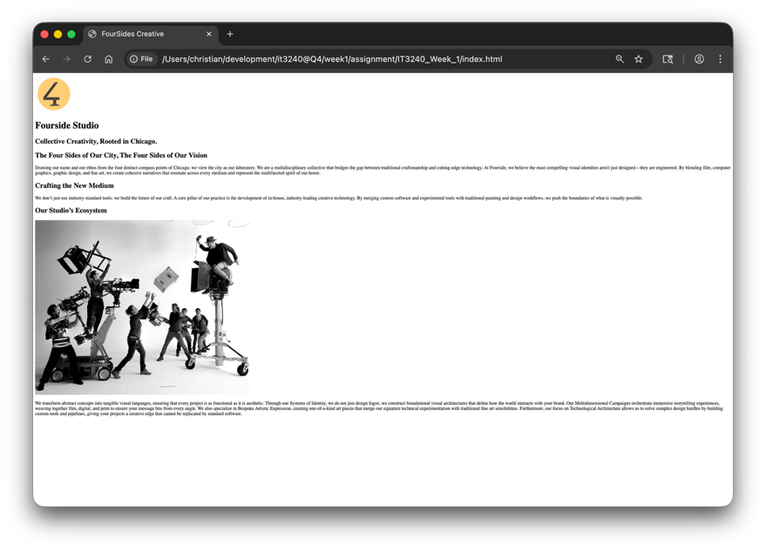
Figure 1. Google Chrome render of the web page
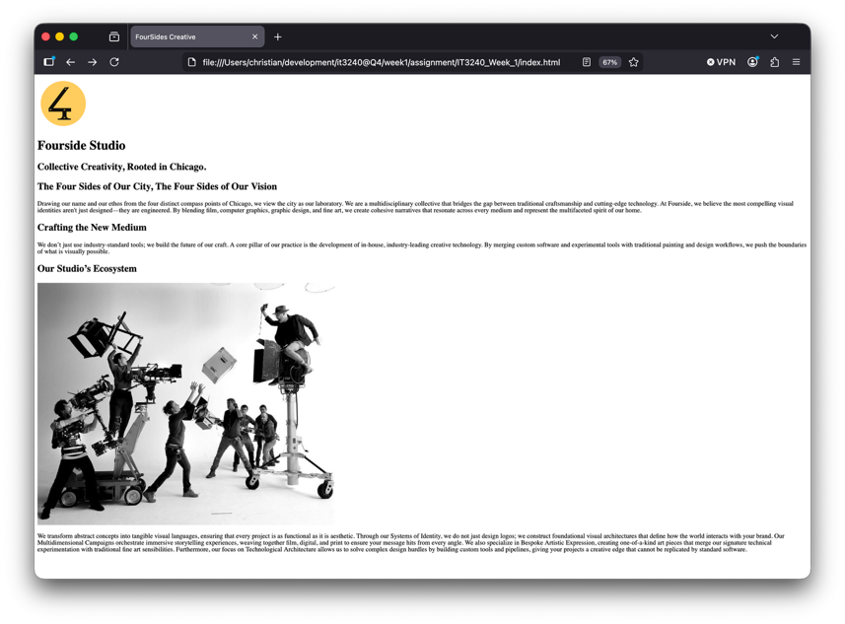
Figure 2. Firefox render of the web page
HTML Validation
The index.html file was validated using the Nu HTML Checker (validator.nu). All errors and warnings were identified and corrected prior to final submission. The validator returned no errors on the final check.
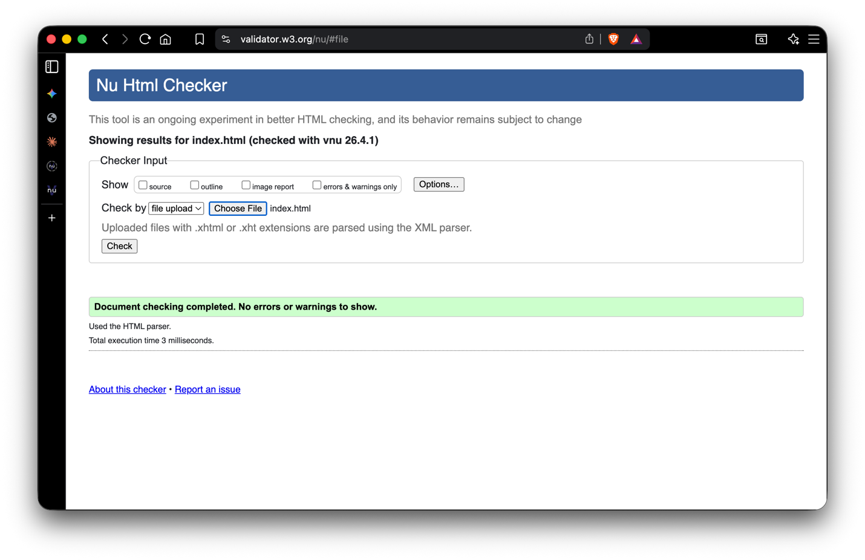
Figure 3. Nu HTML Checker showing valid Html

